
Министерство науки и высшего образования Российской Федерации Федеральное государственное бюджетное образовательное учреждение высшего образования
«Московский государственный технический университет имени Н.Э. Баумана
(национальный исследовательский университет)»
(МГТУ им. Н.Э. Баумана)

Факультет «Информатика и системы управления»
Кафедра ИУ5 «Системы обработки информации и управления»

Курс «Методы машинного обучения»

Отчет по лабораторной работе 7

Выполнил:
студент группы ИУ5-22М Зоров В..В
20.05.2023

Москва, 2023 г.

Лабораторная работа 7. Выполнил Зоров Владислав Витальевич ИУ5-22м. Реализовать алгоритм Actor-Critic для любой среды

In [1]:
import torch import torch.nn as nn import torch.optim as optim import torch.nn.functional as F
import torch.distributions as distributions

import matplotlib.pyplot as plt import numpy as np
import gym import tqdm
In [2]:
train_env = gym.make('CartPole-v1') test_env = gym.make('CartPole-v1')
input_dim = train_env.observation_space.shape[0] hidden_dim = 32
In [3]:
SEED = 1234

train_env.seed(SEED); test_env.seed(SEED+1); np.random.seed(SEED); torch.manual_seed(SEED);
In [4]:
class MLP(nn.Module): def __init__(self, input_dim, hidden_dim, output_dim): super().__init__()

self.fc_1 = nn.Linear(input_dim, hidden_dim) self.fc_2 = nn.Linear(hidden_dim, output_dim)
def forward(self, x): x = self.fc_1(x) x = F.relu(x) x = self.fc_2(x) return x
In [5]:
class ActorCritic(nn.Module): def __init__(self, actor, critic): super().__init__()

self.actor = actor self.critic = critic
def forward(self, state):

action_pred = self.actor(state) value_pred = self.critic(state)

return action_pred, value_pred
In [6]:
In [7]:
def init_weights(m): if type(m) == nn.Linear: torch.nn.init.kaiming_normal_(m.weight)
m.bias.data.fill_(0)
In [8]:
device

=

torch
.
device
(
'cuda'
)

def calculate_returns(rewards, discount_factor, device, normalize = True):

returns = []
In [9]:
output_dim = train_env.action_space.n
op
def train(env, policy, optimizer, discount_factor, device):

policy.train()

log_prob_actions = [] entropies = [] value_preds = [] rewards = [] done = False episode_reward = 0

state = env.reset()
while not done:

state = torch.FloatTensor(state).unsqueeze(0).to(device)

action_pred, value_pred = policy(state)

action_prob = F.softmax(action_pred, dim = -1)

dist = distributions.Categorical(action_prob)

action = dist.sample()
log_prob_action = dist.log_prob(action)

entropy = dist.entropy()

state, reward, done, _ = env.step(action.item())

log_prob_actions.append(log_prob_action) entropies.append(entropy)
value_preds.append(value_pred.squeeze(0)) rewards.append(reward)

episode_reward += reward

log_prob_actions = torch.cat(log_prob_actions) entropies = torch.cat(entropies) value_preds = torch.cat(value_preds)

returns = calculate_returns(rewards, discount_factor, device) advantages = calculate_advantages(returns, value_preds)

loss = update_policy(advantages, log_prob_actions, returns, value_preds, entropies,

return loss, episode_reward
In [10]:
In [11]:
def calculate_advantages(returns, pred_values, normalize = True):

advantages = returns - pred_values
if normalize:

advantages = (advantages - advantages.mean()) / advantages.std()

return advantages
def evaluate(env, policy, device):

policy.eval()

done = False episode_reward = 0

state = env.reset()
while not done:

state = torch.FloatTensor(state).unsqueeze(0).to(device)
with torch.no_grad():

action_pred, _ = policy(state)

action_prob = F.softmax(action_pred, dim = -1)

action = torch.argmax(action_prob, dim = -1)
R = 0 for r in reversed(rewards): R = r + R * discount_factor returns.insert(0, R)

returns = torch.tensor(returns).to(device)
if normalize: returns = (returns - returns.mean()) / returns.std()
return returns
In [12]:
def update_policy(advantages, log_prob_actions, returns, value_preds, entropies, optimizer

returns = returns.detach()

policy_loss = -(advantages * log_prob_actions).mean() value_loss = F.smooth_l1_loss(returns, value_preds)

optimizer.zero_grad()

loss = policy_loss + value_loss * 0.5 - entropies.mean() * 0.01

loss.backward()

optimizer.step()

return loss.item()
In [13]:
In [14]:
state, reward, done, _ = env.step(action.item())

episode_reward += reward

return episode_reward
de
n_runs = 5 max_episodes = 300 discount_factor = 0.99

train_rewards = torch.zeros(n_runs, max_episodes) test_rewards = torch.zeros(n_runs, max_episodes) device = torch.device('cpu')
for run in range(n_runs):

actor = MLP(input_dim, hidden_dim, output_dim) critic = MLP(input_dim, hidden_dim, 1) actor_critic = ActorCritic(actor, critic) actor_critic = actor_critic.to(device) actor_critic.apply(init_weights)
optimizer = optim.Adam(actor_critic.parameters(), lr=1e-2)
for episode in tqdm.tqdm(range(max_episodes), desc=f'Run: {run}'):

loss, train_reward = train(train_env, actor_critic, optimizer, discount_factor,

test_reward = evaluate(test_env, actor_critic, device)

train_rewards[run][episode] = train_reward test_rewards[run][episode] = test_reward
Run: 0: 100%|██████████| 300/300 [01:33<00:00, 3.21it/s]
Run: 1: 100%|██████████| 300/300 [01:40<00:00, 2.99it/s]
Run: 2: 100%|██████████| 300/300 [01:29<00:00, 3.35it/s]
Run: 3: 100%|██████████| 300/300 [01:23<00:00, 3.60it/s]
Run: 4: 100%|██████████| 300/300 [01:23<00:00, 3.59it/s]
In [15]:
idxs = range(max_episodes)
fig, ax = plt.subplots(1, figsize=(10,6)) ax.plot(idxs, test_rewards.mean(0))
ax.fill_between(idxs, test_rewards.min(0).values, test_rewards.max(0).values, alpha=0.1)
ax.set_xlabel('Steps') ax.set_ylabel('Rewards');
In [16]:
x = torch.randn(2, 10) y = torch.randn(2, 10) print(F.smooth_l1_loss(x, y)) print(F.mse_loss(x, y))
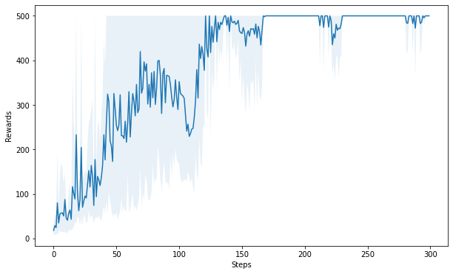
tensor(0.5806) tensor(1.4047)
# This is formatted as code
# This is formatted as code

